Task No & Title: | BSBCMN211A Participate in workplace safety procedures
Title: | Ergonomics Quiz
Suitable for Classes: | Certificate II Business Cert II in ICT
Area: | Technology & Enterprise
Teacher: | Mr Peter Faulks
Timeline | 2 hours
Date Due: | Today

Task Brief:
Files Required | Pen pencil only

Items highlighted in yellow are tasks for you to complete
Items in Blue are help tips

Ergonomic Quiz Written Questions

Note this quiz can be split into several quizzes

Hazards and Controlling Risks
- Can you burn yourself using a printer?
Answer: Explain.
- Where should you place the heavy and light files in a filing cabinet to stop it from falling over?
Answer: Explain.
- In your workplace where should the phone be placed and where is it placed in your workplace?
Answer: Explain.
- What safety precautions should you take with electrical cords on an office?
Answer: Explain.
- What are the principles of safe lifting?
Answer: Explain.
- What is a hazard, and what are the five ways of identifying hazards in an office environment?
Answer: Explain.
- What could result from bad lighting in a work area?
Answer: Explain.
- What is the main aim of working with adequate lighting?
Answer: Explain.
- What is GLARE and what can it be caused by?
Answer: Explain.
- What are some things you can do to control your lighting within your own work environment?
Answer: Explain.

Emergencies
What type of fire extinguisher do you have in your workplace and what fire is it intended to put out? Research and complete the table below.

Type of Extinguisher | Colour | Class of Fire
Water
Foam
Carbon Dioxide
Dry Chemical Powder
Vaporising Liquid

Wet Chemical
Class C Fires
Class D Fires
Class E Fires
Class F Fires

  - If the office was filled with smoke what would you do?
Answer: Explain.
  - Can you be electrocuted from removing parts inside a computer case while it is turned on?
Answer: Explain.
Where are the emergency exits and assembly points in your office? Answer: Explain.
  - In the event of a fire why is it better to go down the stairs instead of the elevator?
Answer: Explain.
  - State where you should find safety equipment including fire extinguishers, emergency units and alarms in an office.
Answer: Explain.

Raising and contributing to OSH Issues

If an employee fails to follow a workplace safety procedure after they have been trained to do so can they themselves be fined by Work Safe?
Answer: Explain.
- Can a worker by sacked for raising a safety concern with Work Safe?
Answer: Explain.
- “A person’s attitude to work is more important than their work routine.” What does this mean in relation to OH&S regulations and accidents?
Answer: Explain.
- What happens if the hazards are not fixed or the employees do not follow the rules and regulations for safety?
Answer: Explain.
- To whom would you report any OHS concerns?
Answer: Explain.

Legislation

1. Explain how the OSH Legislation impacts on an IT Company
Answer: Explain.
2. What are your rights and duties of as an employee and if you were an employer regarding OHS
Answer: Explain.

Ergonomics
1. How far should the monitor be from the user?
Answer: Explain.
2. How high should the top of the monitor be?
Answer: Explain.
3. How high should the chair be?
Answer: Explain.
4. How often should you take breaks when working at the computer?
Answer: Explain.
5. Name 2 ergonomic features of a modern mouse?
Answer: Explain.
6. What is the quickest way when using Windows to increase the zoom to make viewing a document easier?
Answer: Explain.
7. Describe how a computer workstation should be set up, including the positioning of arms, feet, back, keyboard, screen height and distance, chair, table. You should include diagrams with your explanation.
Answer: Explain.

Safety Signs

Matching activity 1- Know that sign - Match each of the pictures to the correct description.
1 2 3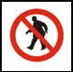 4 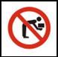 5
6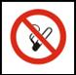 7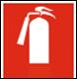 8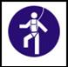 9 10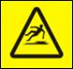
11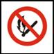 12  13 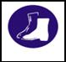 14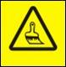 15

Sign | Number is
Wet paint
Keep back straight when lifting
Fire extinguisher
Aisle must be kept clear
Foot protection should be worn
Authorised personnel only
No smoking
Flammable materials No smoking
Telephone
Safety harness must be worn
Slippery when wet
Fire hose
Eye protection must be worn
Head protection must be worn
Safety harness must be worn

Matching activity 2 – Personal Protective Equipment
Match the Personal protective Equipment (PPE) with the risk it is designed to control.
1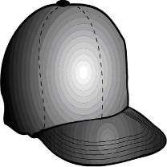 | 2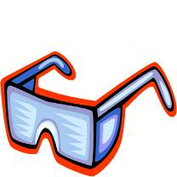 | 3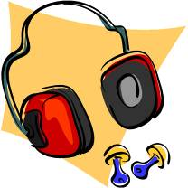 | 4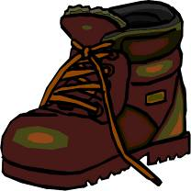
5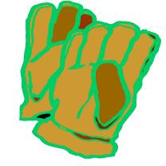 | 6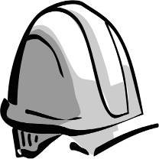 | 7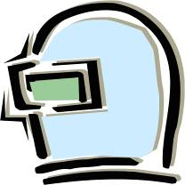 | 8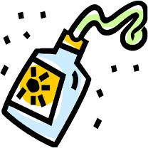

Item | Number is
This protects you from sunburn at outdoor events.
Face, head and eye protection from sunlight at outdoor events
When working with computers or printers that are hot these can protect you from burns
They really help if you drop something on your foot.
When manufacturing or welding, these prevent you from getting debris in your eyes.
Absolutely essential if there is anyone working at height near you.
This prevents you getting flash burns on your eyes when welding.
Ideal for working at very loud Rock Concerts

END of QUIZ

